  Matthew Brown  Senior Healthcare Data Engineer / Senior Technical Analyst /  Software Developer  ABOUT ME  Coffee aficionado dad seeking new problem solving opportunities. I started off digging ditches, sometimes manure, transitioned to a long stint working in various hospital laboratories, eventually progressing to a IT role. I’ve had many side-gigs along the way, but I’m really looking to focus on a single, quality opportunity in the future. Professionally, I consistently find myself in a role where I evolve to be the technical resource for my peers, the guy who can diagnose issues and get things working. I like to build things that matter with people who care.  SKILLS  Python, Javascript (Riot / React), AWS (EC2, ECS, S3, RDS), Docker, Microservice APIs, Git, Shell scripting, Powershell, Unix admin, SQL (PostgreSQL, SQL Server, Oracle, MySQL), Terraform, Ansible, Agile (Jira/Snow/Slack), RPA, Certified Clinical Laboratory scientist, Lab management, Clinical application support & DevOps, Full time work-from-home, Shade-tree boat mechanic  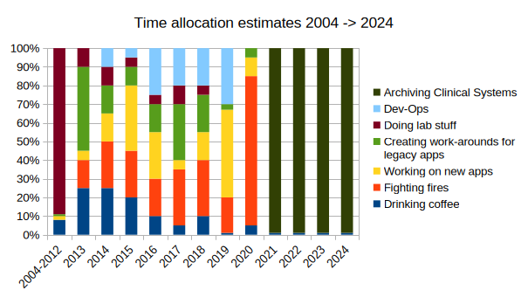 |  | WORK EXPERIENCE  Senior Healthcare Data Engineer  Harmony Healthcare IT (prev. Trinisys) // 2021 → now  End-to-end clinical system archive projects with clients across the United States. SQL/ETL dev using in-house platform Convergence, Python/API development for custom EHR data extraction routines.  Solutions Development Senior Analyst  Ascension Technologies // 2016 → 2021  Mixed bag of Clinical app support , dev-ops, software development, technical liaison, fighting fires. 100% remote on a national team supporting 160+ hospitals across the U.S.  Software developer (consultant)  LenderClose // April 2019 → Oct 2019  Wrote flask-based API additions for a financial app with dev team. Developed AWS dev-ops strategy to deploy microservices (ECS). Some front end work (Riot/React).  Application Analyst (+Technical)  Wheaton Franciscan Healthcare // 2013 → 2016  Supported laboratory information systems (McKesson + Mediware), registration, billing and medical coding apps. Wrote small custom apps for special needs. Tended to babysit anything with an AIX/HP-UX/Linux back-end.  Lab Manager  Specialty Screening // 2016 → 2018  Managed and operated a small CLIA certified lab as a side gig (10-15 hours a week). Wrote custom back-end report system (AutoIT + Crystal runtime).  Medical Laboratory Scientist  Aurora Healthcare // 2007 → 2015  Wheaton Franciscan Healthcare // 2004 → 2012  Maintained two independent MLS jobs at local hospitals (1st, 2nd, 3rd shifts), performing blood banking, hemotology, chemistry, etc. ASCP certified.  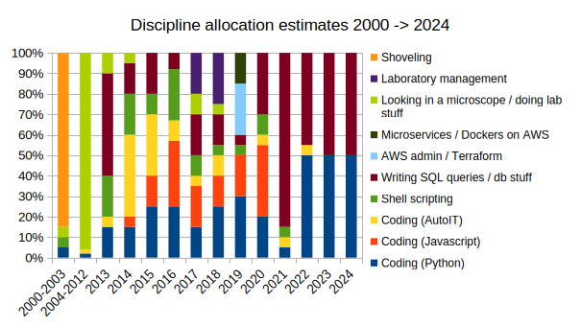  EDUCATION  Bachelors of Science  Michigan State University // 2001  Human Biology  Associate degree  Northern Michigan University // 2003  Clinical Lab Technology
  https://www.linkedin.com/in/matthew-brown-28a968159/
  https://github.com/matthew-brown-mlsci/Resume
  Matthew.Brown.MLS@gmail.com
  Wauwatosa, Wisconsin - 414-241-3490

